Chapter 5, Problem 53

The ordinary difference amplifier for fixed-gain operation is shown in Fig. 5.81(a). It is simple and reliable unless gain is made variable. One way of providing gain adjustment without losing simplicity and accuracy is to use the circuit in Fig. 5.81(b). Another way is to use the circuit in Fig. 5.81(c). Show that:

- for the circuit in Fig. 5.81(a),

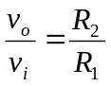

- for the circuit in Fig. 5.81(b),

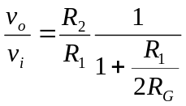

- for the circuit in Fig. 5.81(c),

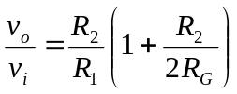

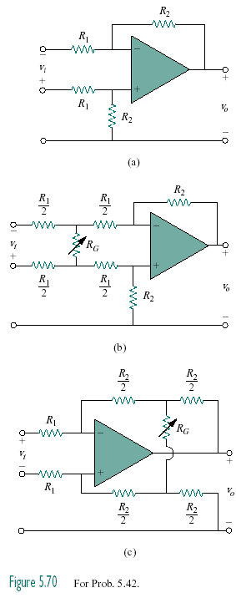

Figure 5.81

